**Introduction:**

This marketplace application is designed to connect buyers and

sellers of custom ceramic plant pots. It includes features like

product browsing, filtering, cart management, and secure

payments.



**Architecture Diagram**

⦁Add a visual representation of the application flow.

Frontend: React → Axios API calls.

⦁Schema for products, users, and orders.

**Migration of provided API**

⦁Provided API to fetch products in my sanity studio

and migrate to my sanity dashboard then fetching

product sanity into my original product page.

**Implementation Evidence:**1. Sanity CMS Dashboard View:  
• Displays populated products entities.  
2. Application Frontend Display:  
• Renders live data seemlessly on the user interface.

**Screen Shot Of Migration:**

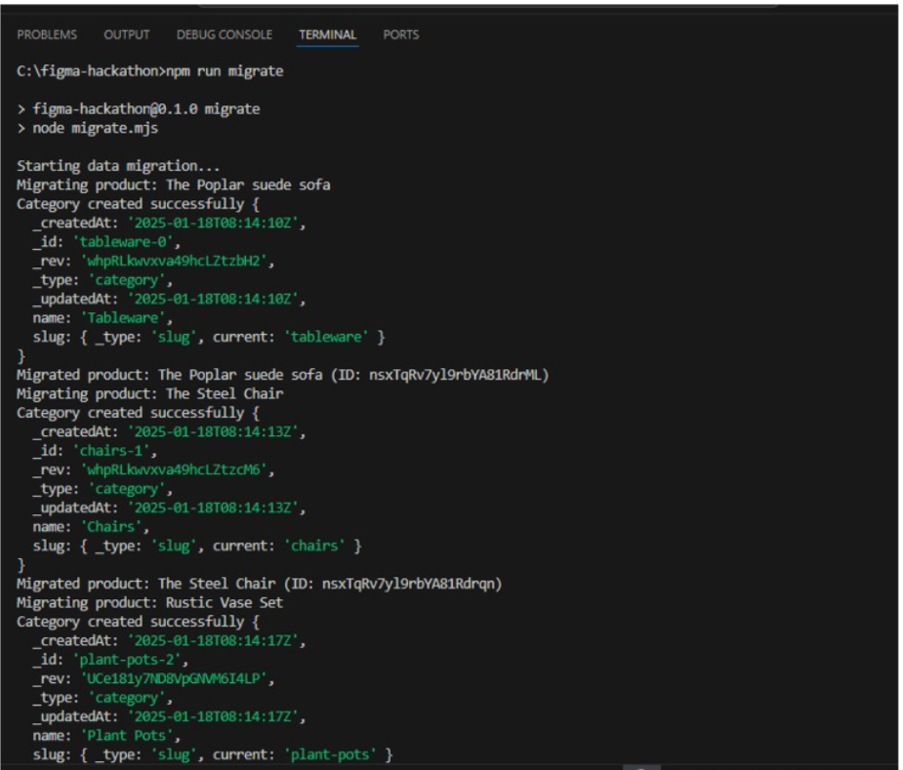

**Screenshot of Product Schema In Sanity:**

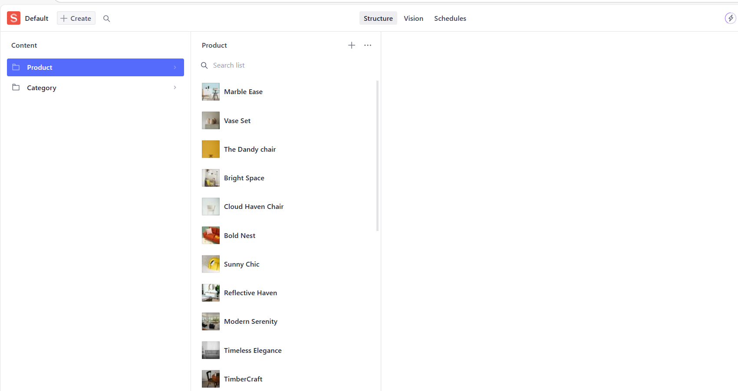

**ScreenShot Of Products Successfully Shown On FrontEnd Page:**

